R. Reports Menu: 5. Cashed Checks Report

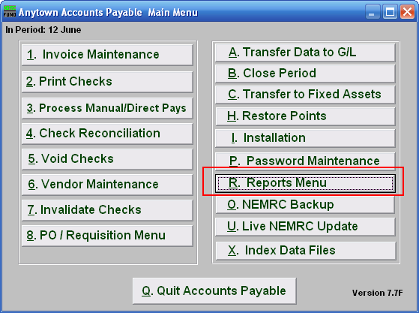
Click on “R. Reports Menu” from the Main Menu and the following menu will appear:
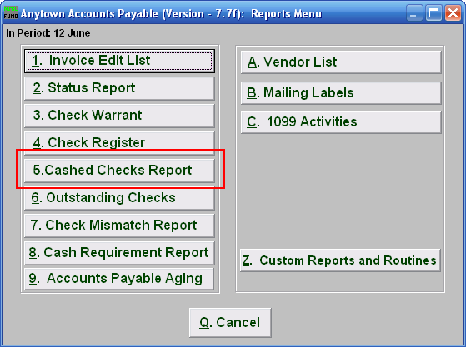
Click on “5. Cashed Checks Report” and the following window will appear:
Cashed Checks Report

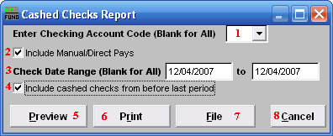
- Enter Checking Account Code (Blank for All): Select the checking account code to report as set up in Installation or leave this field empty to report for all.

- Include Manual/Direct Pays: Check this box to include manual/direct pays made in the date range entered below.

- Check Date Range (Blank for All): Select the beginning and ending check issued dates for collecting data to report.

- Include cashed checks from before last period: Check this box if you are looking for checks that have been cashed and moved to history files during or prior to the last period close. Leave this box unchecked to report only cleared checks during the present period.

- Preview: Click this button to preview. Refer to GENERAL PREVIEW for more information.

- Print: Click this button to print. Refer to GENERAL PRINTING for more information.

- File: Click this button to save on this computer. Refer to GENERAL FILE for more information.

- Cancel: Click “Cancel” to cancel and return to the previous screen.

